|  |  |  |  |
| --- | --- | --- | --- |
|  | |  |  | | --- | --- | |  | **Eastern Goldfields College**  ***Year 12 MATHEMATICS METHODS***  ***TEST 3 2016***  ***Calculator Free*** |   **Name:** |

**Total Marks: 39**

**Reading: 2 minutes Time Allowed: 40 minutes**

**Question 1 (5 marks)**

(a) Simplify . (1 mark)

(b) Solve for , where . (2 marks)

(c) If , determine . (2 marks)

**Question 2 (5 marks)**

Evaluate the following

(a)  *dx*  (2 marks)

(b)  where *k* is a constant. (3 marks)

**Question 3 (8 marks)**

Differentiate the following with respect to , do not simplifying.

(a) . (2 marks)

(b) *y* = *x* log10 (1 + *x*) (3 marks)

(c) 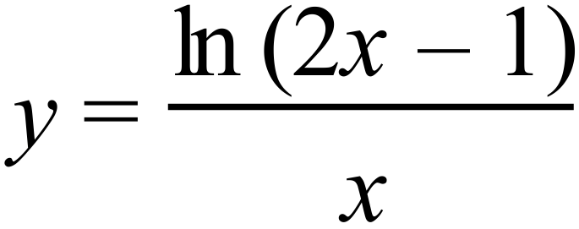 (3 marks)

**Question 4 (4 marks)**

(a) Determine  (2 marks)

Hence,

(b) determine (2 marks)

**Question 5 (8 marks)**

(a) Show that  +  =  (2 marks)

Hence find,

(b)  *dx* (3 marks)

(c) Using your result from part (b), show that the exact value of   
  *dx* = *ln* 2 (3 marks)

**Question 6 (3 marks)**

Find an exact solution for *x* if .

**Question 7 (6 marks)**

Let *y* = ln.

(a) Rewrite *y* as the difference of two logarithms without the radical sign. (3 marks)

(b) Hence, find . You do not need to simplify your answers. (3 marks)

|  |  |  |  |
| --- | --- | --- | --- |
|  | |  |  | | --- | --- | |  | **Eastern Goldfields College**  **Year 12 MATHEMATICS METHODS**  **TEST 3 2016**  Resource Rich |   **Name:** |

**Total Marks: 22**

**Reading: 2 minutes Time Allowed: 24 minutes**

**Question 8 (7 marks)**

(a) Given that  and , find in terms of  and :

(i)  (2 marks)

(ii)  (2 marks)

(b) For each of the following, express  in terms of .

(i)  (1 mark)

(ii)  (2 marks)

**Question 9 (6 marks)**

The annual growth rate for an investment that is growing continuously is given by  where P is the principal and A is the amount after t years. An investment of $10 000 in Dell Computer stock in 2012 grew to $31 800 in 2015.

a Assuming the investment grew continuously, what was the annual growth rate (to 4 decimal places)?

(2 marks)

b If Dell continues to grow at the same rate, what will the $10 000 investment be worth in 2019?

(2 marks)

c Assuming the investment grew continuously at the same rate, how long will it take for the $10 000 investment to grow to $500 000? (2 marks)

**Question 10 (4 marks)**

Match the equation with the graph. (not all equations are used)



y=ln x ______

y=log0.5 x ______

y=log2 x ______

y=ln (x + 1) ______

y=ln (x - 1) ______

y=2 ln x ______

**Question 11 (5 marks)**

The sound level, in decibels (dB), for a single sound of pressure, in millipascals (mPa), is calculated using the formula , .

(a) Determine the sound level corresponding to a sound pressure of 0.02 mPa. (1 mark)

(b) Determine the sound pressure corresponding to a sound level of 80 dB. (2 marks)

1. Sketch the graph of the above function on the axes below with  on the

horizontal axis. Indicate the scale used on the vertical axis. (2 marks)

